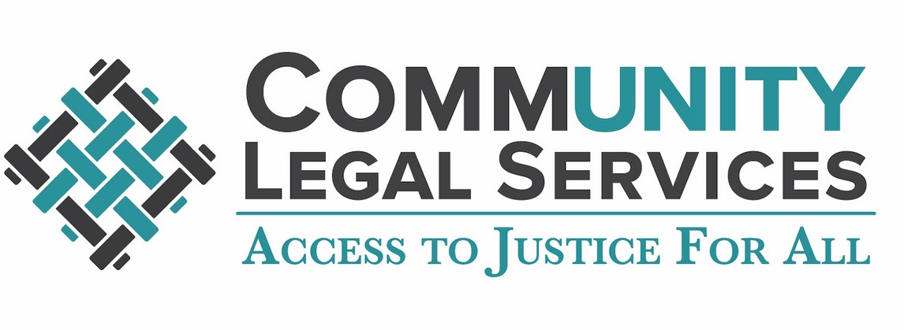



**EQUAL JUSTICE WORKS HOUSING JUSTICE PROGRAM FELLOW**

**PRINCE GEORGE’S COUNTY, MARYLAND**

**Job Details:**

**Term Length: 24 months (2 years)**

**Program: Equal Justice Works Housing Justice Program**

**Start Date: October 1, 2024 (Immediate)**

Community Legal Services, Inc. seeks diverse and dynamic candidates for a 24-month (2 years) full-time attorney position as an Equal Justice Works Fellow in the Housing Justice Program. The Housing Justice Fellow will work closely with our Prince George’s County Eviction Prevention Program which provides free, same-day and extended scope legal representation to low-income tenants facing eviction. This is a full-time, 2-year appointment, which will require in-person court appearances at the Prince George’s County District Court located in Hyattsville, Maryland.

The Housing Justice Program is a two-year fellowship with the targeted mission of disrupting the cycle of evictions and housing instability for low-income tenants by providing free civil legal assistance, community outreach, and advocacy to create systematic change and access to counsel in eviction proceedings.

Equal Justice Works is the nation’s largest facilitator of opportunities in public interest law. An Equal Justice Works Fellowship is an opportunity to transform your passion for equal justice into a career. As a Fellow, you will develop experience and skills to be a leader in social justice while promoting tenant protections and working directly with households experiencing housing instability.

**FELLOWSHIP RESPONSIBILITIES INCLUDE:**

* Providing direct legal services to low-income individuals facing eviction in Failure to Pay Rent, Tenant Holding Over, Breach of Lease, and Wrongful Detainer cases.
* Providing post-eviction housing stability services including security deposit recovery and sealing court eviction records.
* Building key stakeholder relationships in furtherance of the Fellowship objectives; creating, fostering, and cultivating partnerships among legal services providers, tenants’ associations, community social services providers, and other community-based entities.
* Strategizing, planning and conducting training and outreach to communities and community organizations in furtherance of housing stability and affordability for low-income community members; engaging in peer-to-peer learning with other Equal Justice Works Housing Justice Program Fellows.
* Actively contributing to and participating in Housing Justice Program cohort activities (resource exchanges; mandatory webinars and conference calls; and training events, including Equal Justice Works Leadership Development Training in fall 2024 and 2025).
* Exercising leadership competencies as an Equal Justice Works Fellow.
* Contributing to required programmatic reporting and overall program evaluation.

**REQUIREMENTS**

* Juris Doctor from an accredited law school
* Licensed to practice law in Maryland (or the ability to waive in within 2 years from the date of hire)
* Previous direct civil legal services experience, including law school clinics, and/or internships
* Demonstrated commitment to social justice, with a desire to increase access to justice for individuals and communities experiencing housing instability
* Outstanding verbal and written communication skills
* Exceptional interpersonal and organizational skills
* Ability to work collaboratively in a multidisciplinary setting to facilitate a coordinated community response and provide holistic services to clients
* Spanish proficiency is a plus

**LOCATION**

Hyattsville District Courthouse located at 4990 Rhode Island Ave., Hyattsville, MD

**SALARY**

$75,000 or commensurate with experience

**FELLOWSHIP BENEFITS**

* Paid vacation and sick leave
* Health insurance
* Life insurance
* Short and long-term disability insurance
* 403(b) retirement plan

Equal Justice Works Fellows are part of a network of over 2,500 current and former Fellows dedicated to improving access to equal justice for all. As a member of the network, each Fellow has access to: 

* Equal Justice Works’ annual Leadership Development Training
* Responsive training and technical assistance
* Regular substantive and skills-based webinars throughout the Fellowship
* Monthly networking and collaboration sessions with other Fellows

**If interested, please email a resume, cover letter, and references to Deputy Director, Kayla Williams-Campbell, at** [**williams@clspgc.org**](mailto:williams@clspgc.org)

Applications are considered on a rolling basis, candidates are encouraged to apply as soon as possible.

**Equal Opportunity Employer**

CLS is an equal opportunity employer. We value a diverse workforce and an inclusive culture. We encourage applications from all qualified individuals and do not discriminate, and will not tolerate discrimination, on the basis of race, certain traits associated with race, ethnicity, color, religion, sex, pregnancy, gender, gender identity or expression, national origin, sexual orientation, age, national origin or ancestry, genetic information, political affiliation, physical or mental disability, military or veteran status, or any other protected status under federal, state or local law. Our employment decisions are solely made according to qualifications for the positions.

www.clspgc.org